

**Carlstar Tech Tips – Cost saving Ideas Newsletter 11**

Dear Colleagues,

in our quest to save money one area that is a huge cost to the company is password resets. Did you know though that you can reset your password yourself? You can now even reset it when outside the company network without vpn from your computer and mobile device. Below we are going to go over the three methods you can use to reset your password.

1. Via the self-service website. Simply go to <https://selfservice.carlstargroup.com>. Simply click the reset password/unlock account and choose to either reset your password if it is expired or forgotten or unlock if you know your password but it was simply mistyped or something else (another device with a bad password) locked your account.

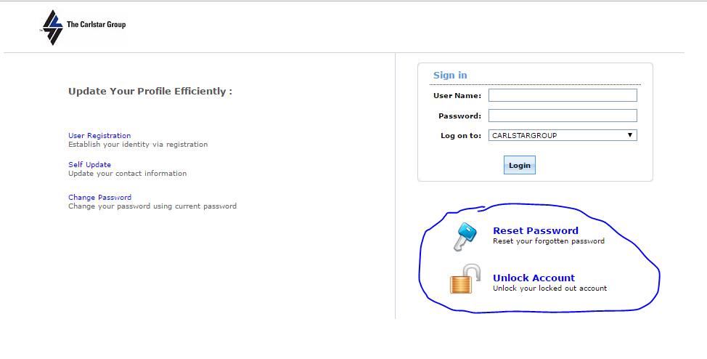

1. Via the change password or login screen. 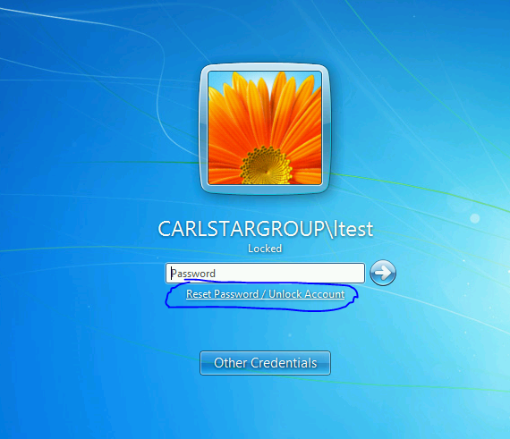

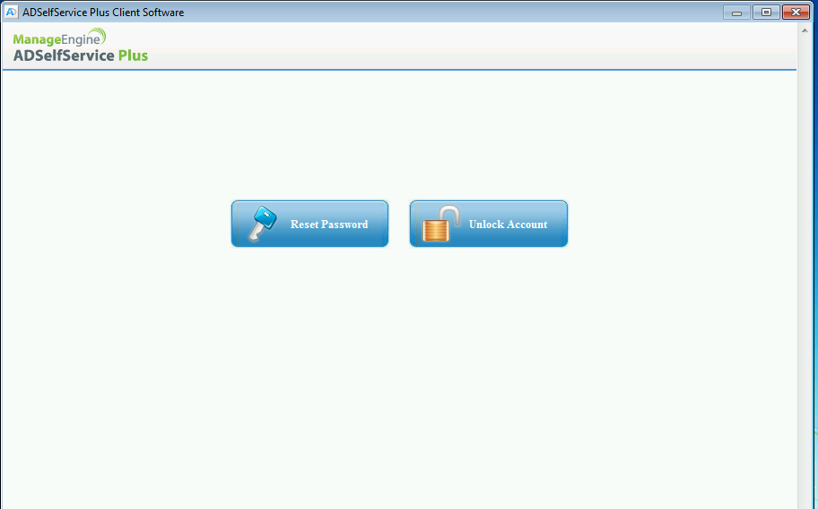

1. Via the AD Self-service application available in the android Play store and Apple App store. We encourage you to download the application prior to your account needing reset or unlocked so it is available.
   1. First open up your app store. For Android it is called play store and for Apple iOS app store.

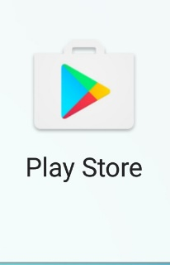

* 1. Search for ADSelfService Plus.

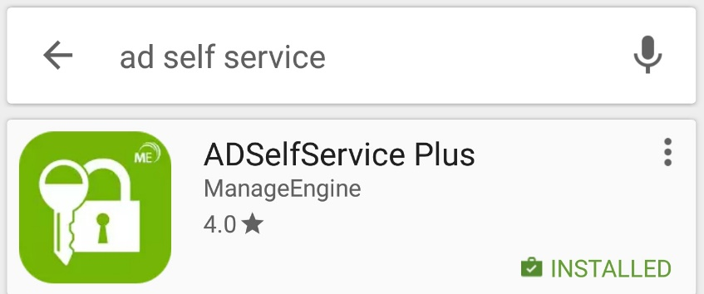

* 1. Touch install (**Make sure and connect to WiFi prior to installing apps**). Once installed touch Open.



* 1. Then choose password reset or account unlock.

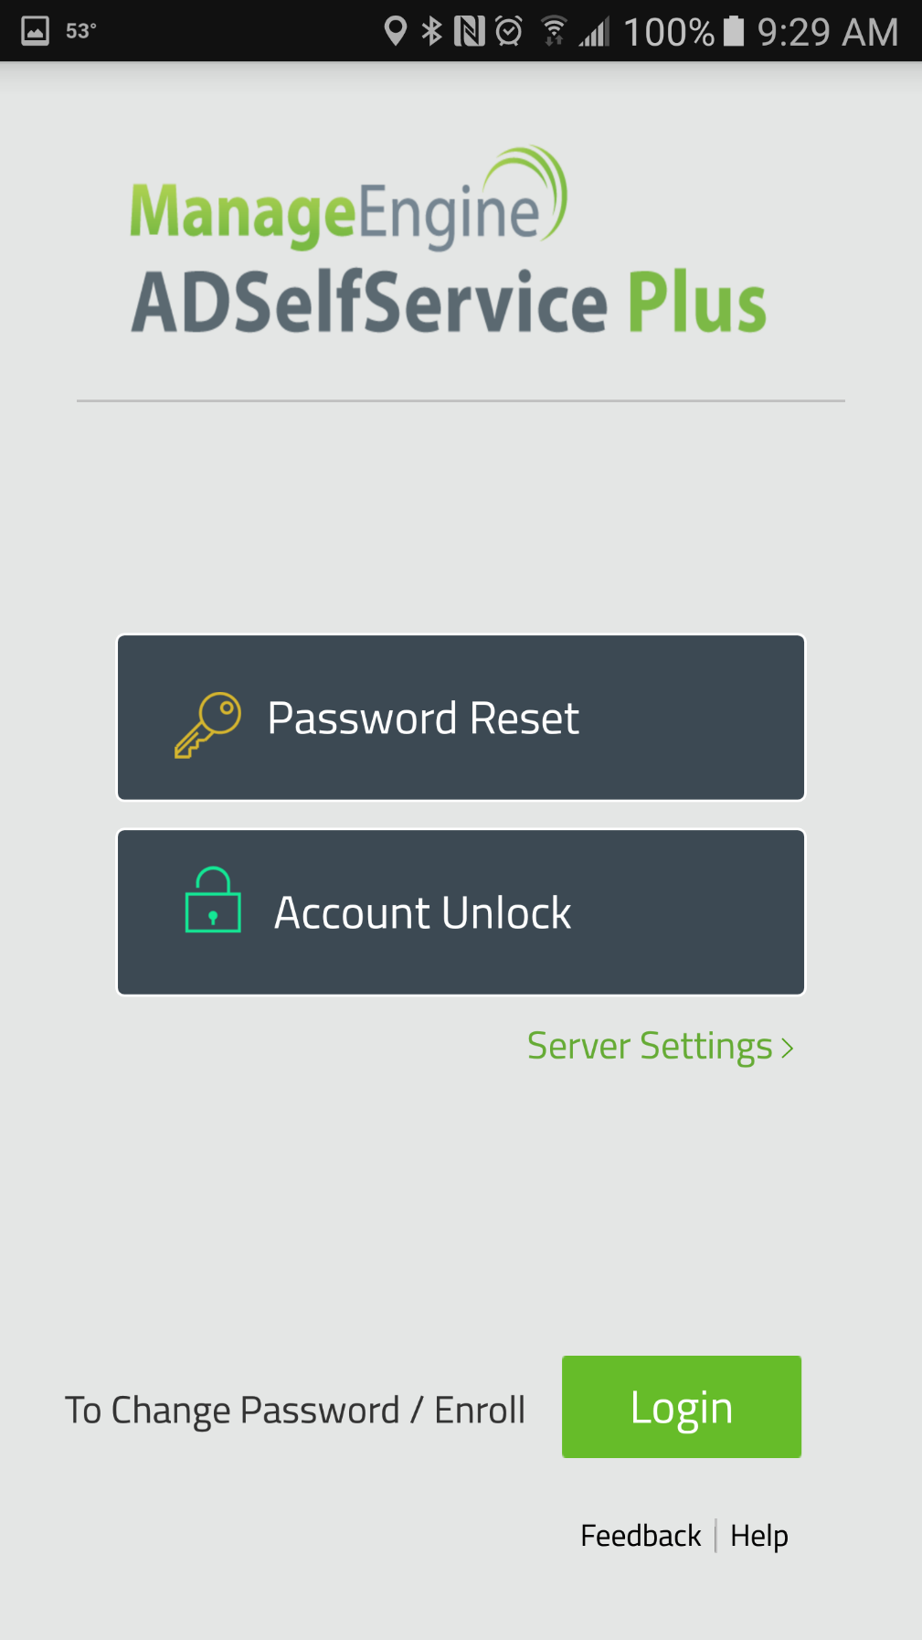

* 1. You will be prompted to enter the AD self-service settings. Simply touch ok.

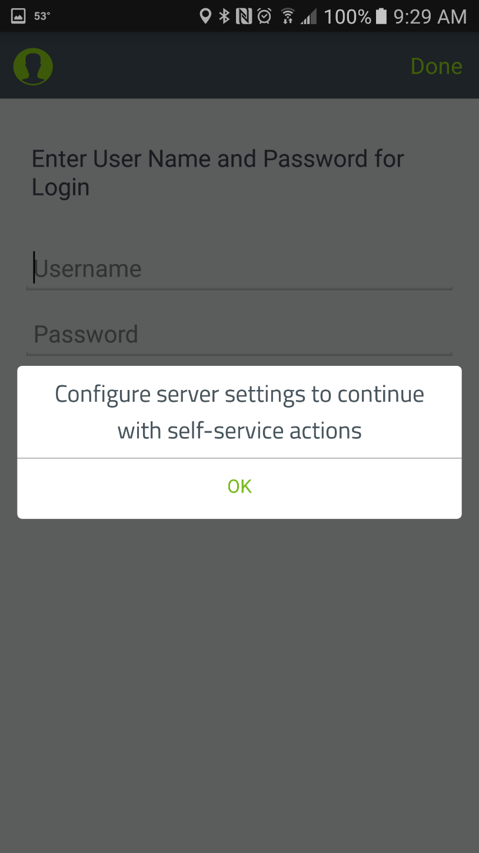

* 1. Turn on https and enter selfservice.carlstargroup.com for the server and 443 for the port as shown below. You will only have to do this step the first time you setup the app.

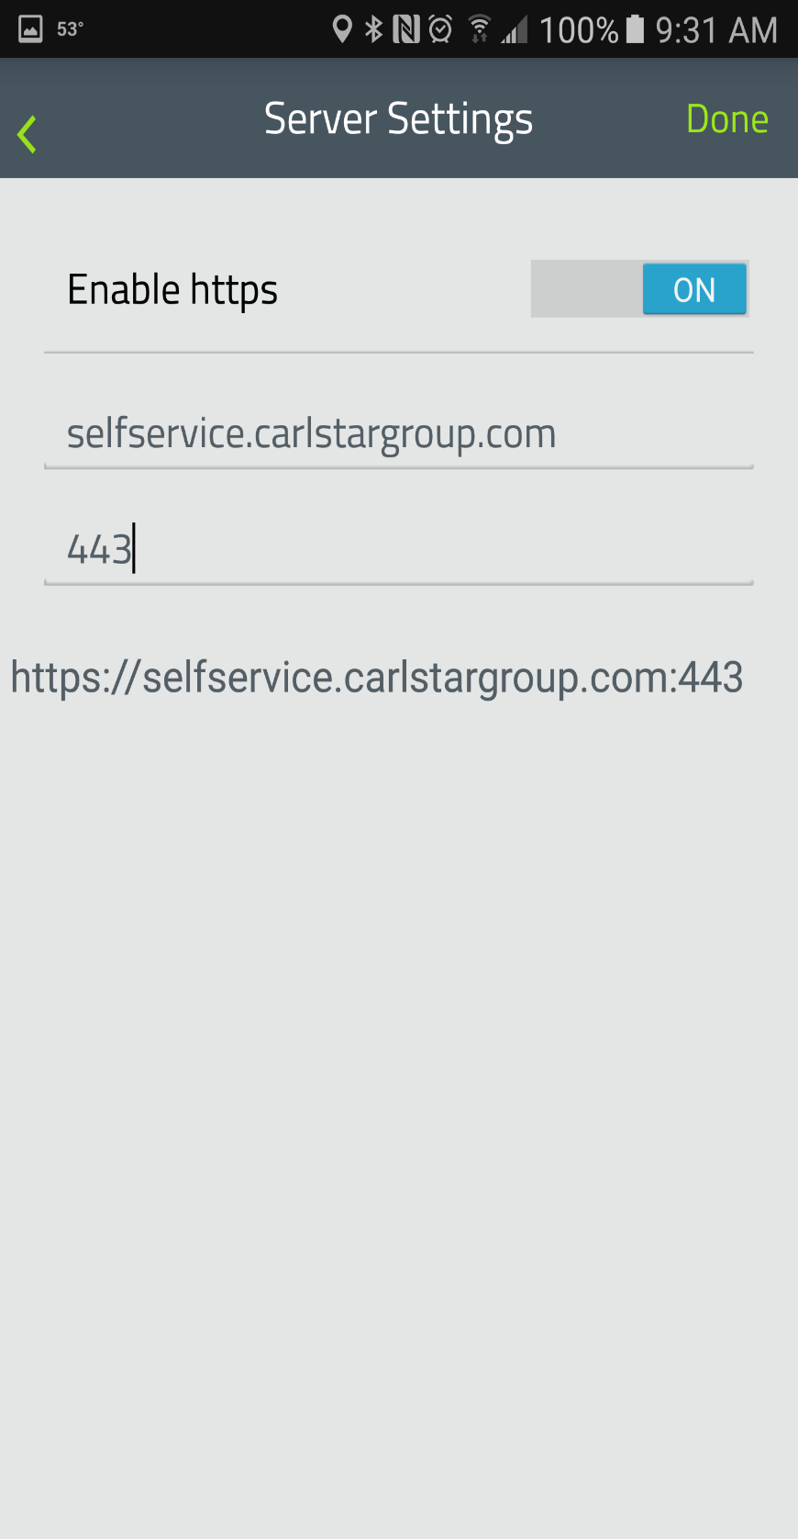

* 1. You will be promoted to setup push notifications. We are not currently using this functionality so touch No. Then hit either password reset or account unlock depending on which option you need.

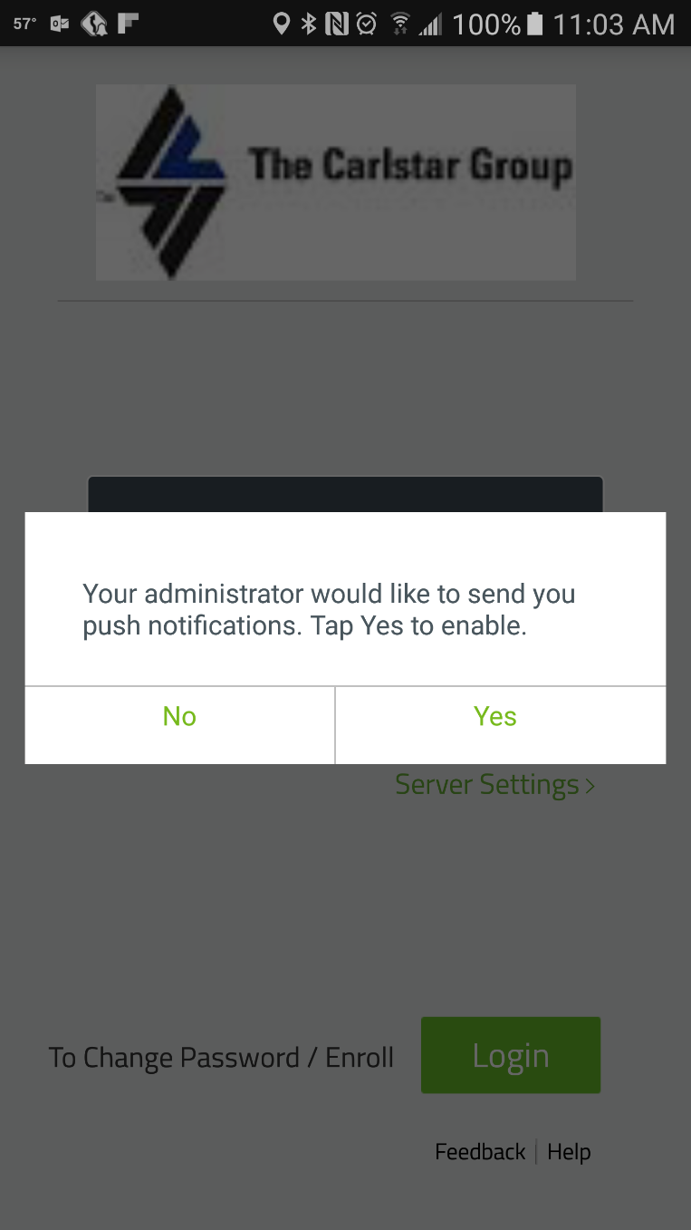

* 1. Type in your username.

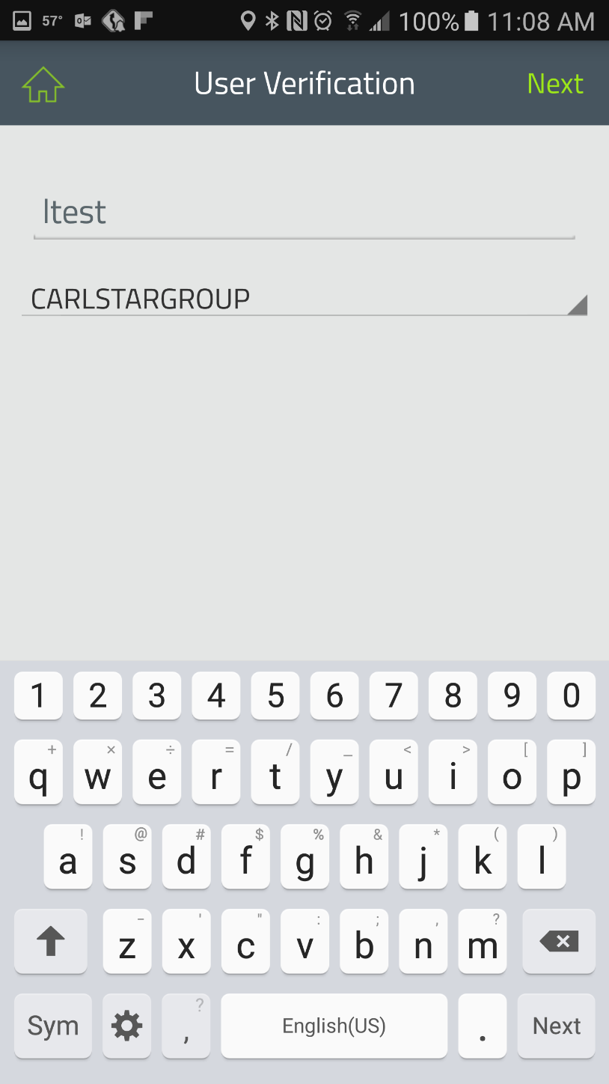

* 1. Enter the answers to the secret questions you previously setup when you logged into your pc for the first time.

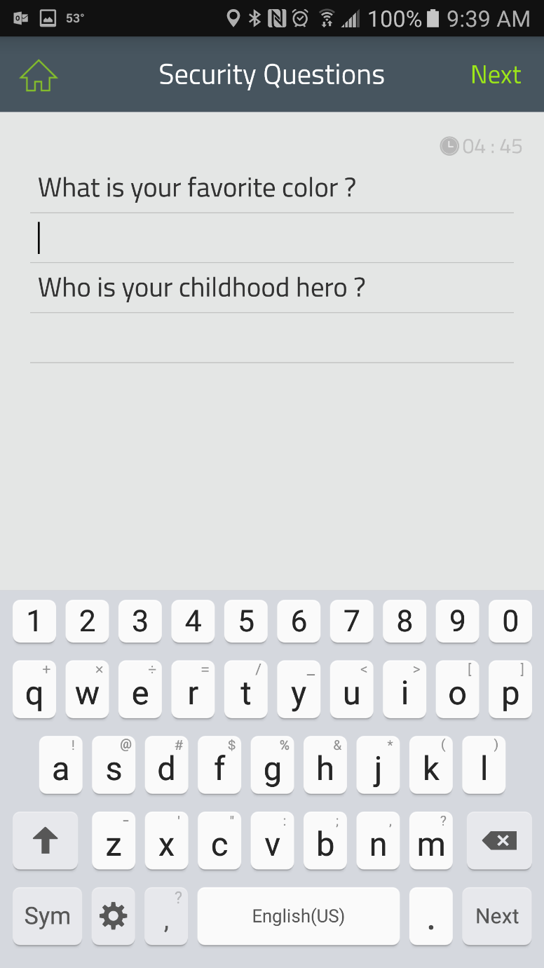

* 1. Then either enter what you want your password reset to or in the case of an unlock like shown below touch unlock.

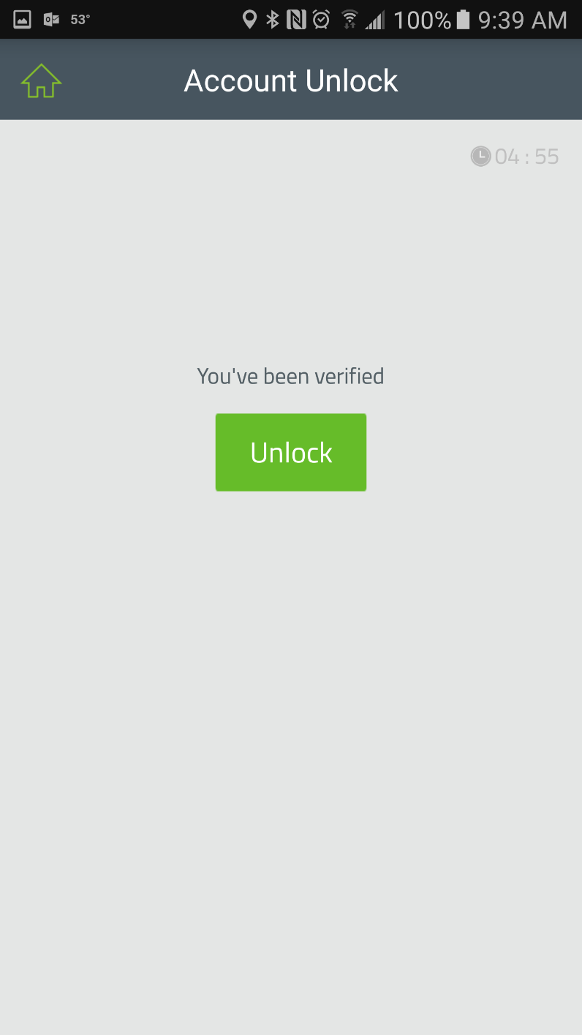

* 1. Success your user account is now unlocked or password reset. You can now get back into your email, laptop, Prism, Lync/Skype etc.

